
Forecasting the Number of Passanger using Sea Transportation within Central Java Area, Using ARIMA (Auto Regressive Integrated Moving Average) Model

Athiya Nahdhiana¹
Dian Nuswantoro University, Semarang - Indonesia
E-mail : 111202013205@mhs.dinus.ac.id¹

Abstract - The sea transportation plays a vital role in Central Java’s economy. It serves as the distribution artery for goods and people, supporting trade and economic growth. The purpose of this study is to predict the number of sea transport passengers being serviced inside Central Java area using the Autoregressive Integrated Moving Average (ARIMA) method. The stages used in the study include: (1) datasets preparation, (2) preprocessing data, (3) experimental and method testing, and (4) accuracy testing. To test the accuracy of the algorithm used Root Mean Squared Error (RMSE) and Mean Squared Error (MSE). The RMSE result is 11520.09739292774 and MSE result is 132712643.94254053 . The ARIMA method was quite accurate in predicting the number of sea transportation passenger.

Keywords - passenger; sea transportation; prediction; ARIMA; MSE

1. INTRODUCTION

Indonesia’s sea transport system is a vital asset due to its vast archipelago of over 17,000 islands. Sea transport play a crucial role in the distribution of necessary goods, benefiting both urban and remote areas. Sea transport ensures the availability of goods and reduces price disparities between Java (the most developed island) and other regions. Efficient sea transport facilitates the movement of goods, supporting trade and economic growth. By providing effective connectivity over sea waters, it enhances inter-island movement and fosters economic development. Central Java, as a key region, benefits significantly from this maritime connectivity. Sea transport is not only vital for Indonesia’s economic prosperity but also plays a critical role in maintaining social cohesion and equitable development across the country. In summary, sea transport remains crucial for Indonesia’s economic activity, especially given its unique archipelagic geography[2].
Central Java, situated on the middle of Java Island, faces both the Java Sea in the north and Indian Ocean in the south. Its strategic location makes it a vital hub for inter-island trade and connectivity. Ensuring well-maintained ports, navigational channels, and berthing facilities is crucial. Central Java must address capacity constraints, especially during peak seasons, to accommodate growing trade and passenger demands. Balancing economic growth with environmental sustainability remains a challenge. Maritime transport affects the environment through pollution (e.g., oil spills, waste disposal) and greenhouse gas emissions [4]. Central Java must tackle these challenges to maintain a robust and sustainable sea transport system that benefits both trade and passengers.

Data-driven insights allow better decision-making for route optimization, fuel consumption, and maintenance schedules. Predictive analytics helps ships take more efficient paths, reducing costs and environmental impact[4]. Sharing data on vessel availability and port capacity helps shipping companies optimize resource utilization. Data science empowers the maritime industry to make informed decisions which lead to improved efficiency.
A time series is a sequence of data points collected, recorded, or measured at successive, evenly-spaced time intervals. Continuously, time series is obtained when observations are recorded continuously over several time intervals. The purpose of time series analysis is generally twofold: to understand or model the stochastic mechanisms that give rise to the observed series and to predict or forecast the future value of the series based on the history of that series or other related factors[3]. Time Series Forecasting is the process of using a statistical model to predict future values of a time series based on past results.
A popular and widely used statistical method for time series forecasting is the ARIMA model. ARIMA stands for AutoRegressive Integrated Moving Average and represents a cornerstone in time series forecasting. It is a statistical method that has gained immense popularity due to its efficacy in handling various standard temporal structures present in time series data.

2. RESEARCH METHOD

ARIMA is a method which overlooks independent variables to make predictions, making it suitable for dependent statistics as well as having some assumptions to be met such as autocorrelation, trend, and seasonality . ARIMA method is able to predict the historical data with the influence of data that is difficult to understand technically and has a high degree of accuracy in the short-term prediction and able to face fluctuations in seasonal data [3].
ARIMA is specified by three order parameters: (p, d, q).
- AR(p) Autoregression – a regression model that utilizes the dependent relationship between a current observation and observations over a previous period.An auto regressive (AR(p)) component refers to the use of past values in the regression equation for the time series.
- I(d) Integration – uses differencing of observations (subtracting an observation from observation at the previous time step) in order to make the time series stationary. Differencing involves the subtraction of the current values of a series with its previous values d number of times.
- MA(q) Moving Average – a model that uses the dependency between an observation and a residual error from a moving average model applied to lagged observations. A moving average component depicts the error of the model as a combination of previous error terms. The order q represents the number of terms to be included in the model.
The stages used in the study include: (1) datasets preparation, (2) preprocessing data, (3) experimental and method testing, and (4) accuracy testing.
A. Datasets Preparation
In this study, the Dataset is named “Jumlah Debarkasi Penumpang Angkutan Laut di Jawa Tengah, 2023.csv” [1], a data compilation of the number of passanger using sea transportation in Central Java within 2020 – 2023 timeframe, downloaded from the official BPS Jateng website. The variable in the Dataset include monthly timeframe and number of the sea transportation passanger in Central Java province.

B. Preprocessing Data
This stage is done before the classification process. At this stage several processes are carried out, include data cleaning, converting factors to numeric, converting factors to date, and test of stationarity. Data cleaning aims to delete missing values. Factor to Numeric conversion is done to change data format from factor type into numeric type[3].
C. Experimental and Method Testing
First, we must make parameter analysis to for the ARIMA model. Identifying the most optimal parameters for an ARIMA model. Then, fitting the ARIMA model with the training dataset. After that, matching the predictions of ARIMA Model against the test set. The result will be the ARIMA model that need to be evaluated before deployment.
D. Accuracy Testing
The purpose of accuracy testing is to show the difference between the actual value of the measurement results. Measurement results can show four possible here, that is accurate and precise, accurate but not precise, precise but inaccurate or imprecise and inaccurate [3]. The accuracy testing is performed using Mean Squarred Error (MSE) and Root Mean Squarred Error (RMSE). The MSE score is the value obtained from the average squared difference between the predicted values and the actual values in a dataset. The lower the MSE, the better a model fits a dataset. Meanwhile, RMSE is obtained from the square root of the average squared difference between the predicted values and the actual values in a dataset. The lower the RMSE, the better a model fits a dataset.
3. RESULTS AND DISCUSSION

Python programming language is a popular choice for data analytic experiment, one of the Python framework we can use is Jupyter Notebook for easy access and stunning data visualisation option. While the dataset is derived from “Jumlah Debarkasi Penumpang Angkutan Laut di Jawa Tengah, 2023.csv” [1], a data compilation of the number of passanger using sea transportation in Central Java within 2020 – 2023 timeframe, downloaded from the official BPS Jateng website.

The Implementation result of ARIMA model in Python using Jupyter Notebook :

Parameter analysis
# Import the library
from pmdarima import auto_arima

# Ignore harmless warnings
import warnings
warnings.filterwarnings("ignore")

# Fit auto_arima function to AirPassengers dataset
stepwise_fit = auto_arima(sea_passanger['Penumpang'], start_p = 1, start_q = 1, max_p = 3, max_q = 3, m = 12, start_P = 0, seasonal = True, d = None, D = 1, trace = True, error_action ='ignore', suppress_warnings = True, stepwise = True)# set to stepwise

# To print the summary
stepwise_fit.summary()
Model fitted to dataset
# Split data into train / test sets
train = sea_passanger.iloc[:len(sea_passanger)-12]
test = sea_passanger.iloc[len(sea_passanger)-12:] # set one year(12 months) for testing

# Fit a SARIMAX(0, 1, 1)x(2, 1, 1, 12) on the training set
from statsmodels.tsa.statespace.sarimax import SARIMAX

model = SARIMAX(train['Penumpang'], order = (0, 1, 1),
seasonal_order =(2, 1, 1, 12))

result = model.fit()
result.summary()

Predictions of ARIMA Model against the test set
start = len(train)
end = len(train) + len(test) - 1

# Predictions for one-year against the test set
predictions = result.predict(start, end,
typ = 'levels').rename("Predictions")

# plot predictions and actual values
predictions.plot(legend = True)
test['Penumpang'].plot(legend = True)

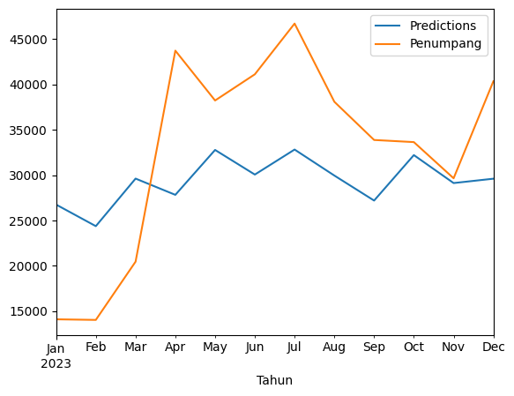
Fig. 1 Graphical Result of the ARIMA Model prediction against the test set
Evaluatation of the model using MSE and RMSE
# Load specific evaluation tools
from sklearn.metrics import mean_squared_error
from statsmodels.tools.eval_measures import rmse

# Calculate root mean squared error
rmse(test["Penumpang"], predictions)
# Calculate mean squared error
mean_squared_error(test["Penumpang"], predictions)

Forecast deployment using ARIMA Model
# Train the model on the full dataset
model = model = SARIMAX(sea_passanger['Penumpang'],
order = (0, 1, 1),
seasonal_order =(2, 1, 1, 12))
result = model.fit()

# Forecast for the next year
forecast = result.predict(start = len(sea_passanger),
end = (len(sea_passanger)-1) + 1 * 12,
typ = 'levels').rename('Forecast')

# Plot the forecast values
sea_passanger['Penumpang'].plot(figsize = (12, 5), legend = True)
forecast.plot(legend = True)

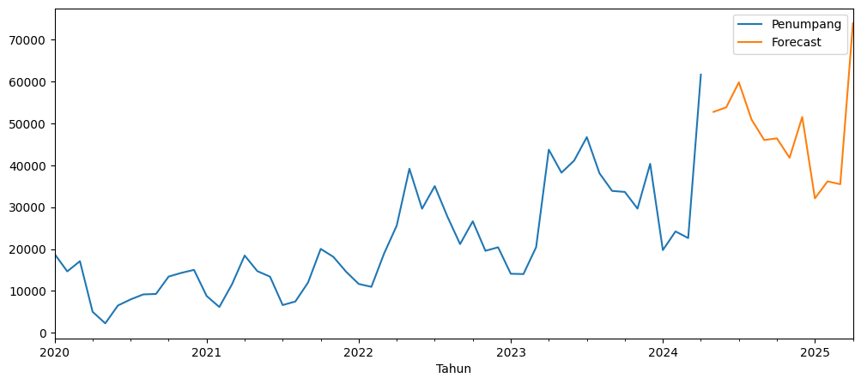
Fig. 2 Graphical Result of the ARIMA Model Forecast

4. CONCLUSION
The Result of the of the number of passenger from year 2024-2025 Forecast are :
Table. 1 Prediction Result of the ARIMA Model Forecast
2024-05-01 51933.459103
2024-06-01 49359.941738
2024-07-01 51864.468877
2024-08-01 41430.609319
2024-09-01 35663.137761
2024-10-01 35071.315911
2024-11-01 30126.881955
2024-12-01 39237.533918
2025-01-01 19880.846413
2025-02-01 23608.916719
2025-03-01 22734.460477
2025-04-01 59760.032941
Freq: MS, Name: Forecast, dtype: float64

The RMSE result is 11520.09739292774 and MSE result is 132712643.94254053 for the forecast of the number of passenger from year 2024-2025.
Efficient resource management based on passanger forecast could be a better method for both the National and Regional Goverment in regards to the development of Sea Transportation.
So, it can be concluded that ARIMA model is a viable method to forecast the number of sea transport passengers in Central Java area, it might be possible to be even more accurate if the model use more data.

REFERENCES (IEEE) :
[1]Badan Pusat Statistik Provinsi Jawa Tengah, “Jumlah Debarkasi Penumpang Angkutan Laut di Jawa Tengah - Tabel Statistik,” Bps.go.id, 2024. https://jateng.beta.bps.go.id/id/statistics-table/2/MTc5MyMy/jumlah-debarkasi-penumpang-angkutan-laut-di-jawa-tengah--orang-.html (accessed Jul. 13, 2024).
[2]F. Zen and M. H. Yudhistira, “Maritime Policy and Eastern Indonesia Development,” Economic Research Institute for ASEAN and East Asia, ERIA Annex Office: Sentral Senayan II 6TH Floor, Jakarta, Mar. 2022. Accessed: Jul. 13, 2024. [Online]. Available: https://www.eria.org/publications/maritime-policy-and-eastern-indonesia-development
[3]T. Widiyaningtyas, Muladi, and A. Qonita, “Use of ARIMA Method To Predict The Number of Train Passenger In Malang City,” IEEE Xplore, Mar. 01, 2019. https://ieeexplore.ieee.org/document/8834663
[4]H. Benamara, J. Hoffmann, and F. Youssef, “Maritime transport: The sustainability imperative,” Psaraftis, Harilaos N, Ed., Springer International Publishing, 2019, pp. 1–31. doi: https://doi.org/10.1007/978-3-030-04330-8%E2%82%81.

